MS16 Varicose veins: Assessment
Definition: tortuous, dilated superficial veins

Epidemiology
Very common – about 1 in 3 people over 40
Prolonged standing, family history, female, age, anything that increases pressure on pelvic veins (high BMI, pregnancy)
Pathophysiology
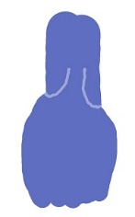
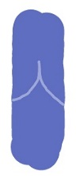
Veins contain one-way valves
Increased pressure from above pushes valve leaflets apart
Vein below leaflets dilates
Return through the vein becomes sluggish
Clinical Features
High venous pressure – heavy legs, visible varicosities, thread veins, night cramps, restless legs, throbbing, heat, burning feet
Impaired microcirculation at ankle level – haemosiderin, lipodermatosclerosis, inverted champagne bottle leg

Complications
Superficial thrombophlebitis (red, hot, tender vein) from venous stasis, bleeding, venous eczema, venous ulceration

Varicose Vein History
How long? Any h/o DVT or PE? Female patients:
Ever treated before? FH DVT or PE? Family finished?
What symptoms? Leg fracture or immobilisation? Vulval varices?
Ever bled or had phlebitis? Patent foramen ovale? Miscarriages?
Ever had an ulcer or eczema?

Varicose Vein Examination
Ask patient to stand, expose legs
Comment on distribution of varicosities
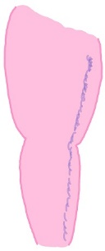
Long saphenous distribution
Most common
Runs down antero-medial side leg anywhere from groin to ankle

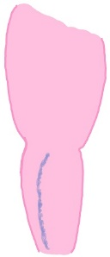
Short saphenous distribution
Runs down posterolateral calf only

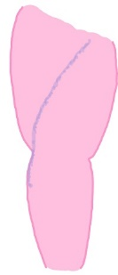
Anterior accessory
Runs diagonally across front of thigh before winding around lateral side of knee

Comment on venous skin changes
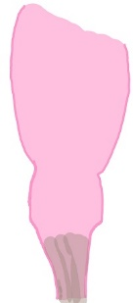
Inverted champagne bottle leg?
Gaitre haemosiderin?
Scars from old ulcers (usually medial gaitre area)?
Lipodermatosclerosis – pinkish patches in haemosiderin, area looks hard and woody?

Traps for the unwary
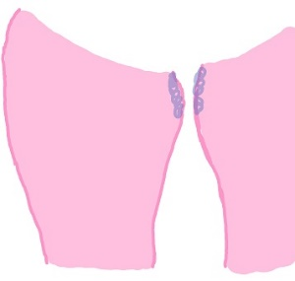
Varices upper inner thighs only
Often sign of pelvic varices

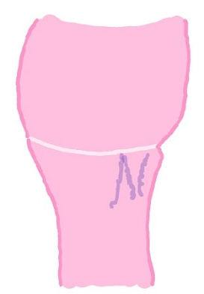

Varices posterior thigh heading to gluteal fold
Sign of pelvic varices

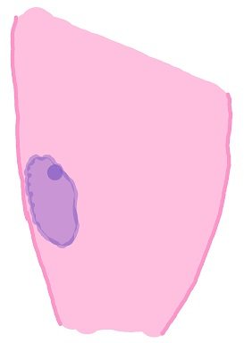
Large diffuse ‘varices’ in unusual spots e.g. lateral thigh
Beware AV malformation
Feel for buzzing
Listen for machinery murmur

