MS14 Aortic Dissections
Pathophysiology

Aortic wall is like layers of an onion
3 layers: inner intima, middle media, outer adventitia
If inner intima weakens, may tear
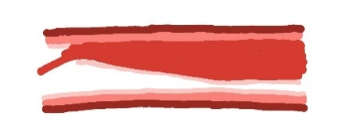
Blood gets in between the wall layers through the intimal flap
Blood flow ‘dissects’ the intima away from the media, narrowing or blocking the lumen
OR
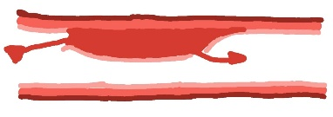
Pressure in the dissection may tear another hole in the intima downstream, allowing blood to re-enter the true lumen
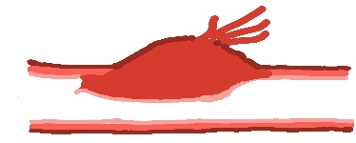
OR
Pressure may cause aneurysmal dilation leading to aortic rupture

Patients might have mixed patterns e.g one branch blocked while another is reperfused due to a re-entry flap

Epidemiology
Incidence: 3 to 4 / 100000 / year
Risk factors: High BP (chronic or acute e.g heavy lifting); connective tissue disorders e.g Marfans; pre-existing aneurysm; family history; aortic instrumentation; infective or inflammatory vasculitis

Presentation
Classically ‘tearing’ interscapular pain with marked hypertension and radio-femoral delay
In reality multiple potential presentations depending on dissection type, location and progression
Patients often misdiagnosed initially e.g as MI or PE
Dissection then picked up on investigations

Classification
Multiple classification systems

Easiest is A and B

Type B
Dissection starts Beyond left subclavian artery (B = Beyond subclavian)
Problems occur downstream – chest, spinal cord, abdominal organs, legs


Type A
Less common
Dissection starts proximal to left subclavian artery
Progresses retrograde around the Arch (A for Arch)
Problems occur upstream – brain, heart

Diagnosis
Contrast CT
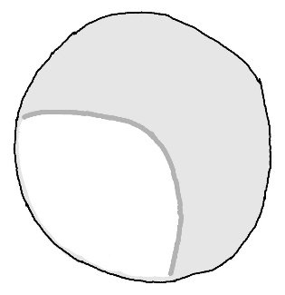
Best seen in cross section (axial) views
Aortic lumen looks like it has split in two
True lumen usually smaller and whiter (higher flow so more contrast)
False lumen usually larger and more gray than white ( lower flow, less contrast and possibly more thrombus)

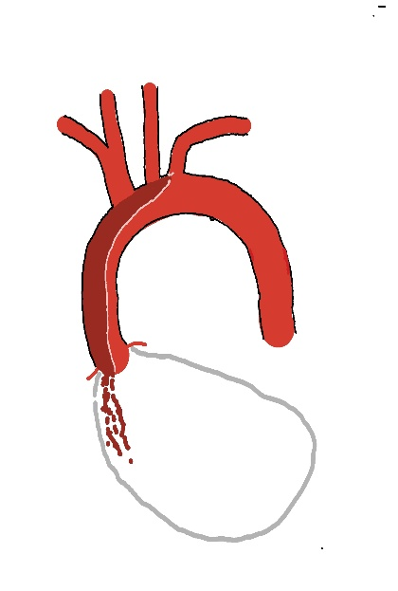
Complications
Type A
Blood dissects from edge of left subclavian artery back towards the heart
May cause stroke if it blocks off left common carotid or brachiocephalic arteries
May reach coronary artery origins at root of aorta = Myocardial ischaemia
May then rupture into pericardium = cardiac tampons

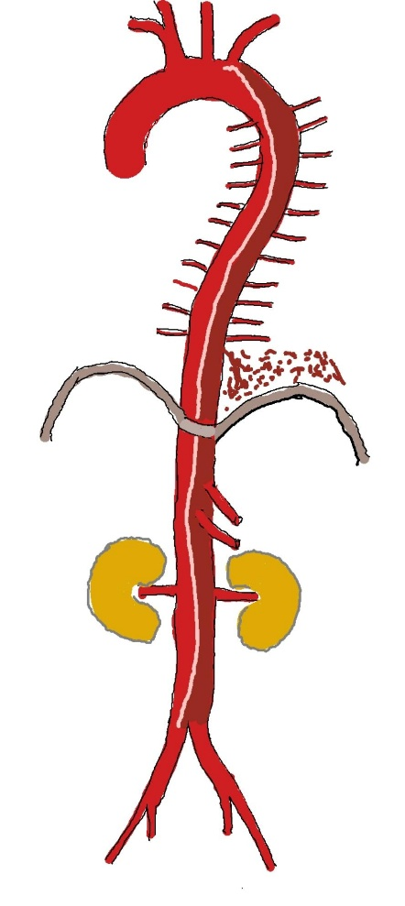
Type B
Blood dissects from just distal to left subclavian artery towards the legs
May compromise intercostal arteries leaving the patient vulnerable to spinal cord ischaemia
May rupture into left side of chest = haemothorax
Next big branch it might block = coeliac axis = liver, splenic ischaemia
Superior mesenteric artery lies just distal to coeliac axis = mesenteric ischaemia if blocked
Next major branches are renal arteries = renal failure or infarction if blocked
Dissection may reach aortic bifurcation and usually progresses down one iliac = acute limb ischaemia if blocked
Practice Point: Radio-femoral delay ( the femoral pulse comes slightly after the radial rather than simultaneously) may be a sign of Type B dissection. It is a ‘soft’ sign though – people often think it is present on examination when the patient is well while dissection patients often have no radiofemoral delay. Don’t get caught out by assuming ‘no radiofemoral delay’ = ‘no Type B dissection’!

Management
Type A
- Surgical emergency
- Call cardiothoracic surgeons
- Oxygen, IV access, full blood count, urea & electrolytes, clotting, cross match
- Do not waste time – Type A dissections have a very high mortality from coronary ischaemia and tamponade
Type B
- Acute if < 2 week history
- Chronic if > two week history
- Acute
- Oxygen
- IV access
- Full blood count, urea & electrolytes, clotting, cross match, pain relief
- Often very hypertensive (systolic > 200mmHg) – labetolol infusion to reduce blood pressure and slow progression
- High dependency unit for invasive blood pressure monitoring
- May need surgical intervention if end organ dysfunction e.g. femoro-femoro crossover if presents with an ischemic leg or mesenteric bypass if bowel ischemia
- Try to avoid intervention on the dissection itself in the acute phase

- Chronic
- Dissection more established
- Usually do not have acute end organ dysfunction
- Intervention depends on extent, rate of expansion, chronic end organ dysfunction e.g. renal impairment

