MS12 EVAR Complications
Classify:
- General (occur any with operation)
- Vascular – occurring with any major vascular procedure
- EVAR specific

General Complications
- Bleeding
- Infection
- Venous thromboembolism
- Hypersensitivity reactions
- Chronic pain
- Scarring

Any Major Vascular Procedure
- 🫀 Heart attack (Risk 1 in 50)
- Stroke (Risk 1 in 100)
- Renal failure (Risk 1 in 100)
- Death (usually from heart attack or stroke)

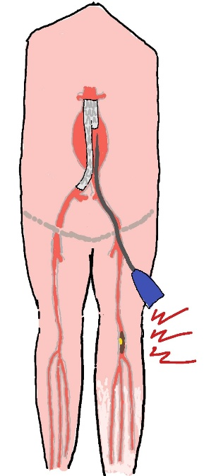
EVAR Specific

Limb Ischaemia / Loss
Risk 1 in 50
Often have pre-existing peripheral arterial disease
Sometimes large stent delivery devices damage access vessels
Low flow distal to large introducers – thrombosis in situ
Clot forming around introducers- embolus
Produce acute / acute-on-chronic ischaemia perioperatively

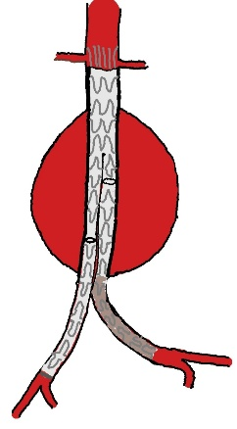
Graft limb thrombosis
May occur any time
May produce:
- Acute limb ischaemia
- Claudication
- Chronic limb threatening ischaemia

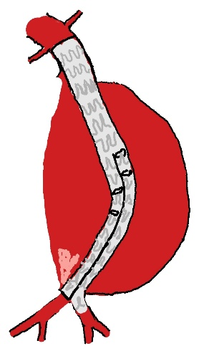
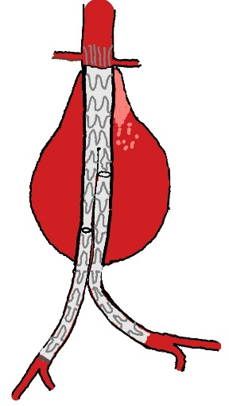
Type 1 Endoleak
The seal at the top or bottom of the stents fails
Can be immediate or over time
1a = leak at top
1b = leak at bottom (b for bottom)
AAA is pressurised again so risk of rupture

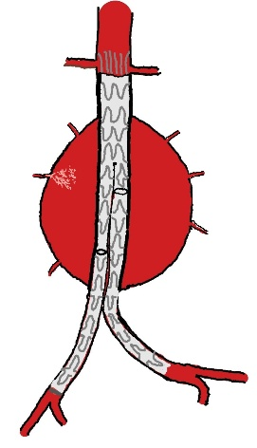

Type 2 Endoleak
Most common
Can occur any time
Backbleeding from small branches into the sac
Generally can just be watched
Embolism branch if sac expanding

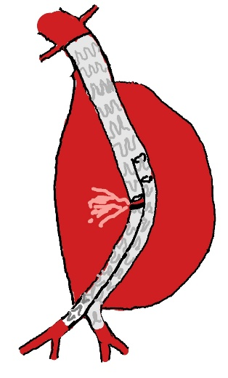
Type 3 Endoleak
Graft sections disconnect
AAA re-pressurises so rupture risk

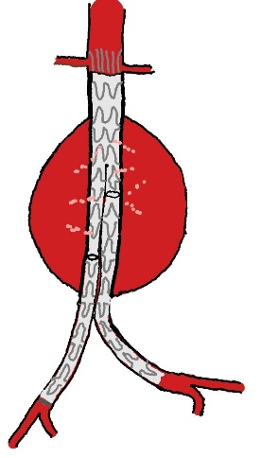
Type 4 Endoleak
Blood seeps through pores in the graft fabric
Uncommon
Difficult to diagnose
May just see sac expansion

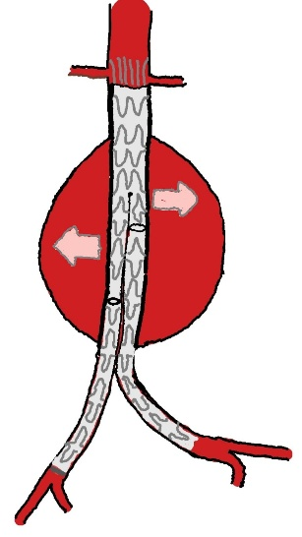
Type 5 Endoleak (Endotension)
Poorly understood
Sac expands
No obvious leak
May be transmitted pressure through stent via sac thrombus

