MS11 RUPTURED ABDOMINAL AORTIC ANEURYSM
Epidemiology
Incidence 10/100,000 men per annum
Decreasing
M > F though women with AAA more likely to rupture

Risk Factors
AAA size (<4cm = 0% per annum; 5 to 5.9cm = 3 to 15% per annum; 6 to 6.9cm = 10 to 20% per annum)
Expansion > 0.5cm in 6 months
Continued smoking
Uncontrolled hypertension
AAA in women seem to expand faster so are more prone to rupture

Clinical Features
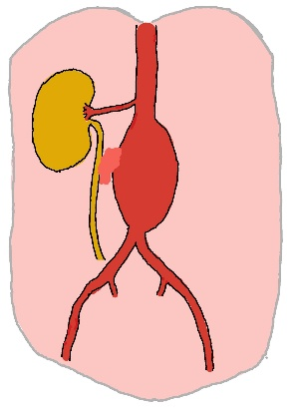
Classic triad (present in about half): back or abdominal pain, hypotension and pulsatile abdominal mass
Other presentations:
Contained leak irritating the ureter – Beware the middle-aged man with ‘renal colic’ but with no blood in the urine
Fainting with sudden back pain – retroperitoneal rupture causes an initial sharp drop in BP – patient faints then recovers as BP recovers and a slow retroperitoneal trickle continues
Very rarely, AAA may rupture into the adjacent inferior vena cava (aortocaval fistula) presenting with features of high output cardiac failure
Practice Point: Medicine is full of old myths. One is that a patient with palpable femoral pulses cannot have a ruptured AAA. It’s not true...believe it and you'll get caught out

Diagnosis
Ultrasound will demonstrate an AAA
Contrast CT is needed to rule out a contained rupture and to evaluate suitability for EVAR
Practice Point: Remember an ultrasound can only tell you an AAA is present (and in very obese individuals it might struggle to do that). An ultrasound cannot rule out a contained rupture. Only a contrast CT can do that

Initial Management
Call the vascular and anaesthetic teams
High-flow oxygen
2 large bore cannula
Blood for full blood count, renal function, clotting, cross match
Analgesia
12 lead ECG
IV fluids... cautiously
Practice Point: in patients with a contained leak, clot or the peritoneum is keeping them alive. Sudden surges in BP might dislodge clot or tear the peritoneum. As long they are talking and oriented their BP is fine. Don't aggressively pour in fluids to get the BP up.

Definitive Treatment
Open or endovascular repair
No difference in short term outcomes but rupture patients treated with EVAR do better in the medium term (3 years)
EVAR tends to be first choice, if available

