MS10 ABDOMINAL AORTIC ANEURYSMS
Definition: an aneurysm is an abnormal dilation of a blood vessel to greater than 50% above it's normal diameter. An abdominal aorta greater than 3cm diameter is considered aneurysmal

Epidemiology
2 to 8% men over 65
0.5 to 2% women over 65
168000 deaths globally in 2013, up from 100000 in 1990

Risk Factors
Smoking - most AAA patients have smoked at some point
Male gender
Family history - brothers of AAA patients 4x to 6x risk
Connective tissue disorders e.g. Ehler-Danlos
Infection
Trauma
Arteritis

Classification
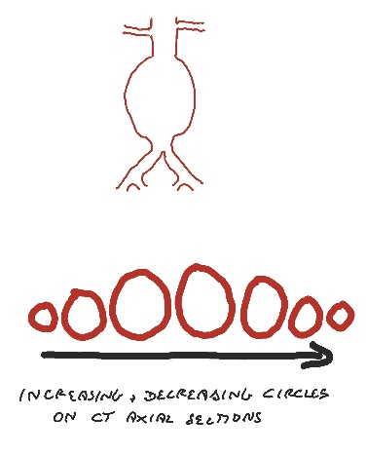
Shape: fusiform or saccular
Fusiform
Most common
Usually degenerative, occasionally connective tissue disorder
Involves full circumference of aortic wall
On CT scan look like circles
Rupture risk related to max diameter

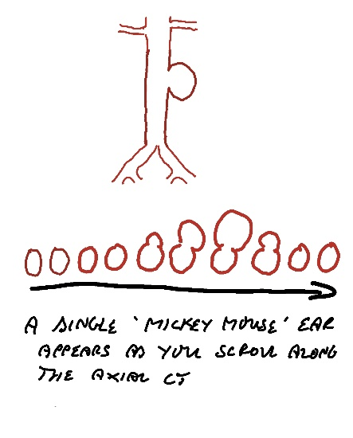
Saccular
Less common
Often mycotic
Involves just an arc of the aortic circumference
On CT looks like a one-eared Mickey Mouse
Can rupture at any size

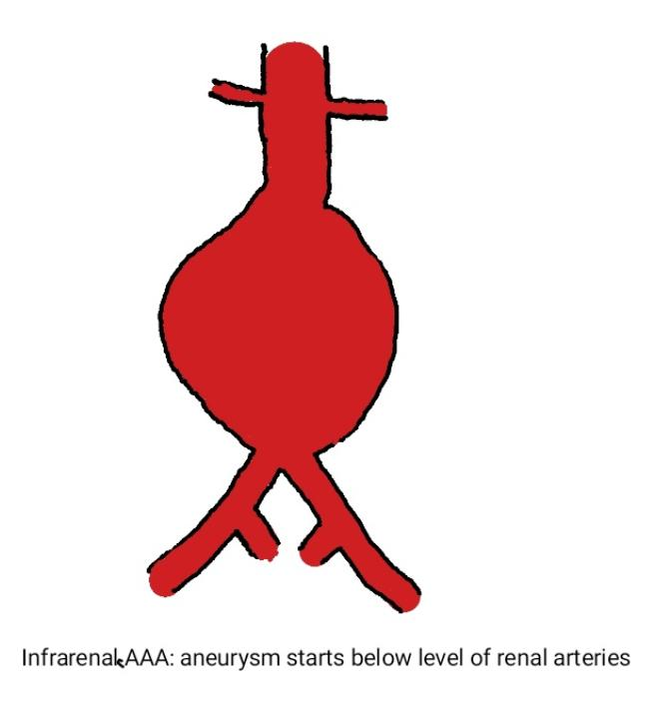
Location: infrarenal, juxtarenal or suprarenal
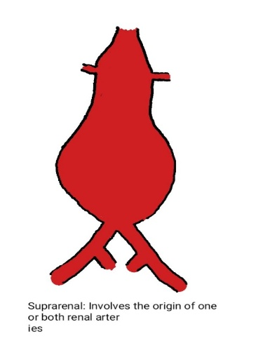
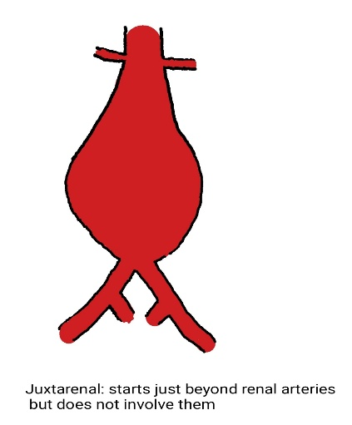

Clinical Features
Mostly asymptomatic
Occasionally patients notice abdominal pulsation
Occasionally patients develop back pain
Most AAA are picked up incidentally when a patient has e.g. a lumbar MRI for long standing mechanical back pain or a staging CT for colorectal or lung cancer
Some countries e.g. UK run a national screening programme for AAAs so have screen- detected patients

Assessment of an AAA patient with incidentally detected AAA
History
Back pain? Recent onset back pain in a patient with no prior history of spinal issues is a worrying feature. Patients with a long history of back issues who now have been found to have an AAA can usually be reassured the AAA is NOT the cause of the pain.
Abdominal pain?
Active or previous smoker?
Family history AAA?
High blood pressure? High cholesterol?
Leg or chest pain on walking?
Previous heart attack / stroke/ coronary intervention?
Short of breath on exercise? Ankle swelling? Short of breath in bed at night?
Examination
Palpate abdomen: previous scars? Tender AAA?
Check Femoral and popliteal pulses: aneurysmal?
Check for signs of heart failure: ankle oedema, crepitations on chest auscultation, raised JVP etc

Management
Stop smoking: smoking cessation reduces rupture risk and rate of expansion
Optimise blood pressure control
Ensure has secondary prevention prescribed (anti- platelet and statin)
Duplex ultrasound to establish diameter
< 5.5cm = surveillance with regular ultrasound, >5.5cms consider intervention if fit

Practice Point: Management of AAA patients involves balancing risks. Small 3 and 4cm AAAs do rupture but it is rare. The mortality risk of intervention is fixed so for small AAAs the risk of surgery to repair them is generally much larger than the risk of rupture with surveillance. It is important the patient and their family understand that this is a question of balancing relative risks and trying to do no harm to the majority of patients.

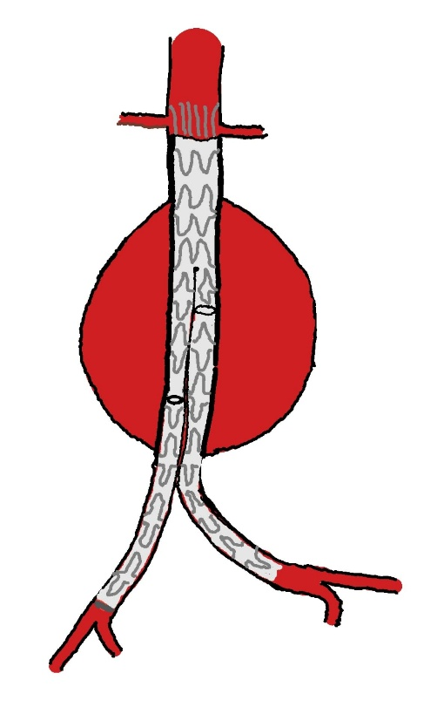
Intervention Options
Endovascular repair (EVAR)
Covered stents introduced through femoral arteries under x-ray control
Reline aorta from just below renal arteries to just above internal iliac arteries so all pressure taken off aortic wall
Usually come in two or three pieces which have to be connected up inside the vessels
Shorter hospital stay and reduced early complications
Need surveillance as pieces may slip, disconnect or crumple
Up to 40% need re-intervention for a stent related issue in the first 2 to 3 years

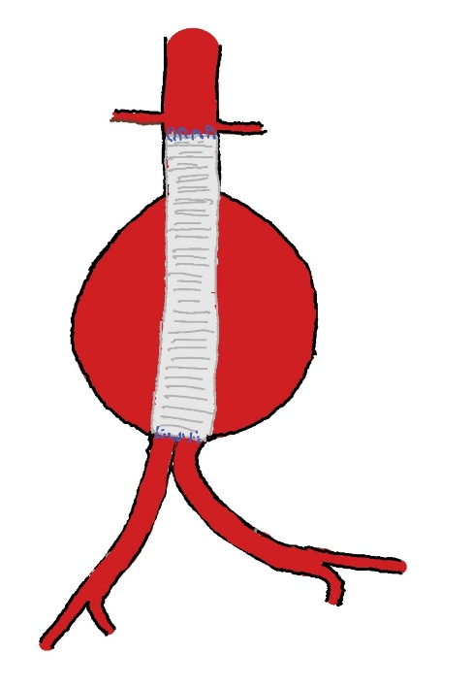

Open Repair
Dacron graft is sutured inside the aorta
Requires laparotomy
Longer hospital stay and higher early complications
May have fewer late complications than EVAR
May be preferred option in younger patients with life expectancy of 10 years or more
Must be fit for the procedure

