MS09 Introduction to lower limb revascularisation procedures
Lower limb revascularisation procedures are increasing
May be open surgical or endovascular
More complex disease is leading to increased use of hybrid procedures where a combination of open and endovascular techniques are used to restore flow
Basic Principles
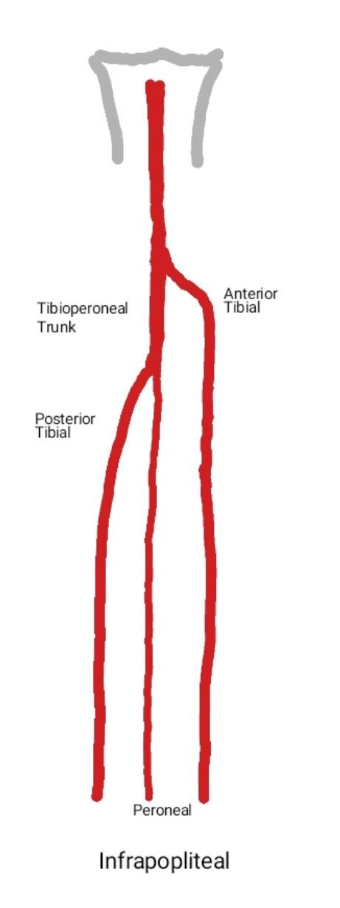
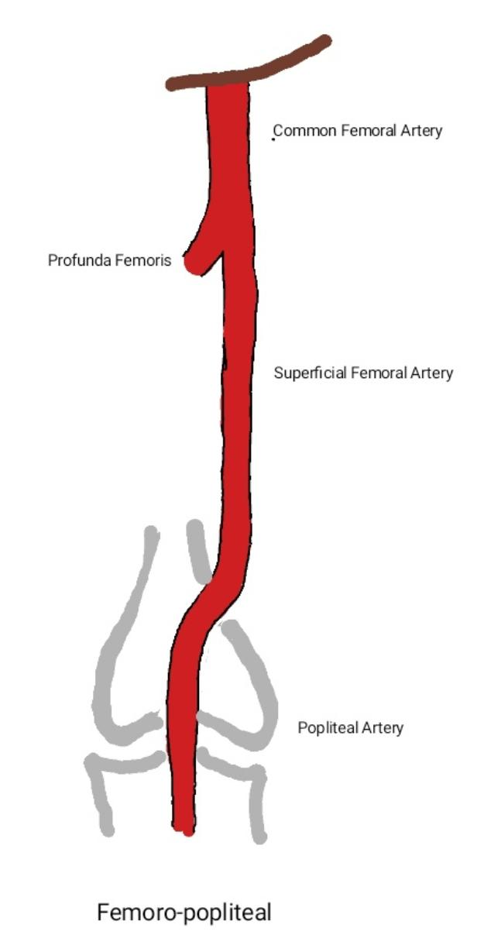
3 anatomical levels for consideration
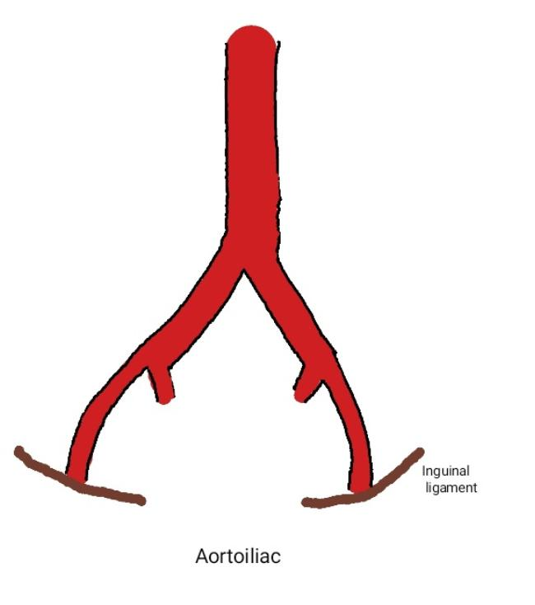
Work from top down – no point fixing the femoro-popliteal segment if there is still a problem in the plumbing above that!
Rest pain- usually settles if top level of disease sorted
Tissue loss- need to get inline flow from aorta all the way to the tissue loss level
Keep it as simple as possible

Possible Procedures
Bypass
Angioplasty
Endarterectomy

Common Bypass Procedures
Used for long blockages or multiple blocks / narrowing
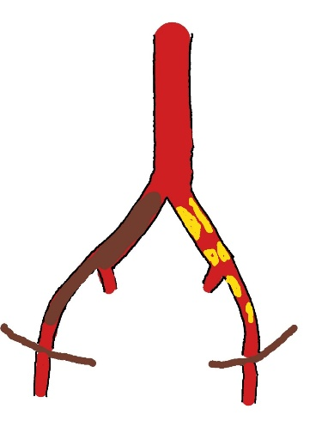
Aorto-bifemoral Bypass
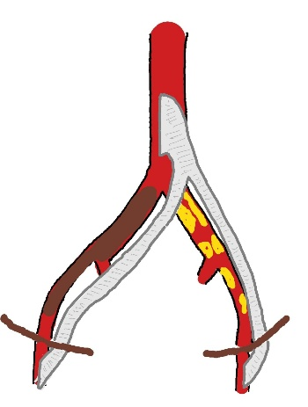
Used for blocked / stenos distal aorta or iliacs
Open abdomen and expose common femoral arteries in groin
Suture Dacron graft to front of aorta and run limbs through retroperitoneum to suture onto front of common femoral arteries

Femoro-popliteal Bypass
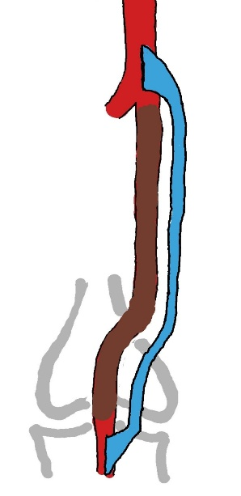
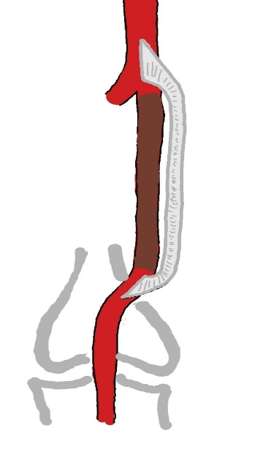
Used for superficial femoral artery which is blocked or has multilevel stenosis
Take flow from open artery and run a new pathway for blood down to where the blocked artery reforms
Can use prosthetic or vein
Above knee, prosthetic and vein have similar patency rates so usually use prosthetic to bypass above knee
Below the knee, vein has better patency so usually use vein to bypass to below the knee

Endarterectomy
Involves opening an artery and clearing out the blockage / narrowing
In the leg, mainly used in common femoral artery
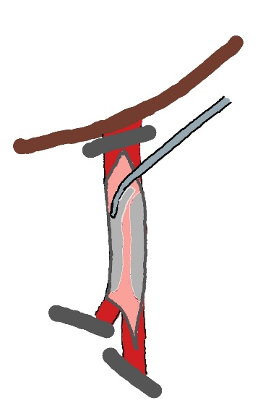
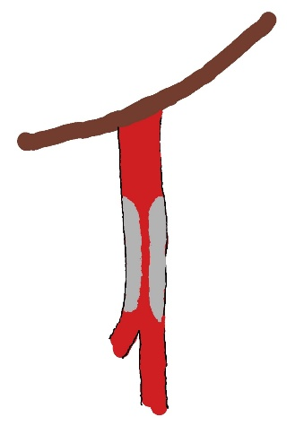
Common Femoral Endarterectomy
Common femoral stenoses tend to be very calcified so do not respond well to angioplasty
Stents behave poorly as lesions calcified, area crosses a joint and the vessel branches
Preferred approach is to open groin, clamp artery and clear out the plaque
Prosthetic patch then used to widen artery
Sometimes may be combined with a bypass

Transluminal Angioplasty / Stenting
Originally used for short narrowing or blocks
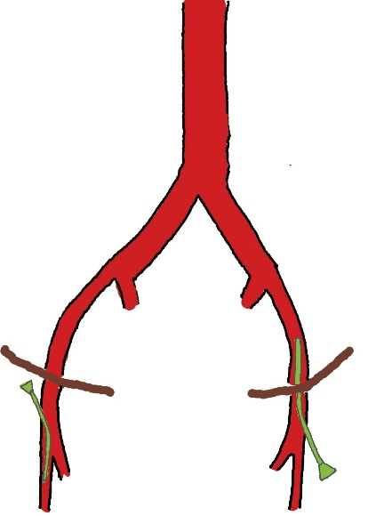
Gradually use has increased in longer lesions

Plastic sheath placed in common femoral artery
Faces up the iliac to treat lesions above the inguinal ligament
Faces down the superficial femoral artery to treat anywhere below the level of common femoral

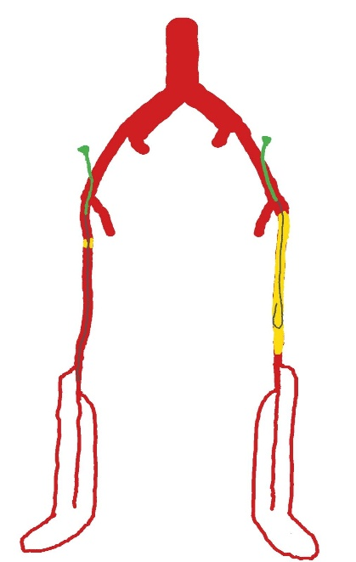
Angiogram ideally from aorta to toes before any manipulation
Wire then passed across the lesion under x-ray control
Usually straightforward with a short lesion (left)
Long blocks (right) often need a subintimal angioplasty where a loop of wire is run down through the artery wall to create a new channel
Once wire through, balloon placed across the lesion and inflated
Different balloon sizes and lengths used depending on size of native artery and length of lesion
Once lesion ballooned repeat angiogram to assess result
Once ballooning finished, repeat angiogram to toes before removing sheath
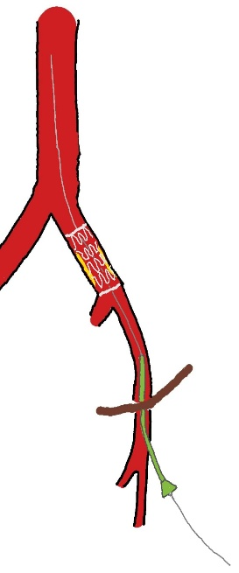
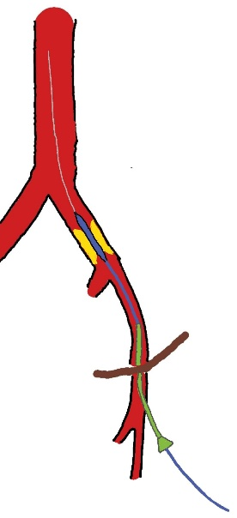
In the iliac arteries, after a narrowing is reopened with a balloon, a stent is often deployed to hold it open
Below the inguinal ligament, most people only use stents in certain specific situations e.g recurrent narrowing

Complications of lower limb revascularisation
Common...these are not the fittest patients!
Both open and endovascular procedures can be complicated by: limb loss, myocardial infarction, congestive cardiac failure, disabling stroke, death, renal failure requiring dialysis, bleeding, infection, reocclusion, pseudoaneurysm
Careful weighing of risks vs benefits is needed before any patient has a procedure

Pros & Cons of Open and Endovascular Approaches
Open | Endovascular
Requires incision | Percutaneous
Scarring may make repeat open procedures more difficult | No scarring so subsequent open surgical access not compromised
General or spinal anaesthetic | Local anaesthetic
Longer recovery time | Shorter recovery time
May have better long-term durability | Less long term durability
Generally choose the most straightforward option to get your patient out of trouble and keep them out of trouble for as long as possible

