MS08 Acute Limb Ischaemia

Definition: Sudden reduction in limb perfusion which threatens limb viability

Epidemiology
Incidence 0.014% US adults per annum
30 times Iess common than CLTI
True ALI has been decreasing for many years
Conversely, acute on chronic limb ischaemia has been increasing

Risk Factors
Atrial fibrillation
Myocardial infarction
Smoking
Atherosclerosis
Previous lower limb revascularisation

Practice Point: Beware sudden limb pain in someone whose regular anti- coagulation has been held to facilitate a 'minor’ surgical procedure e.g. skin lesion excision. These patients are prone to ALI

Clinical Features
The classic 6 Ps
Early (the situation is retrievable): Pain Pallor Pulseless Perishing Cold
Late (the situation may be unsalvageable): Paraesthesia (ischaemic neuropathy); Paralysis (ischaemic myopathy)

Causes
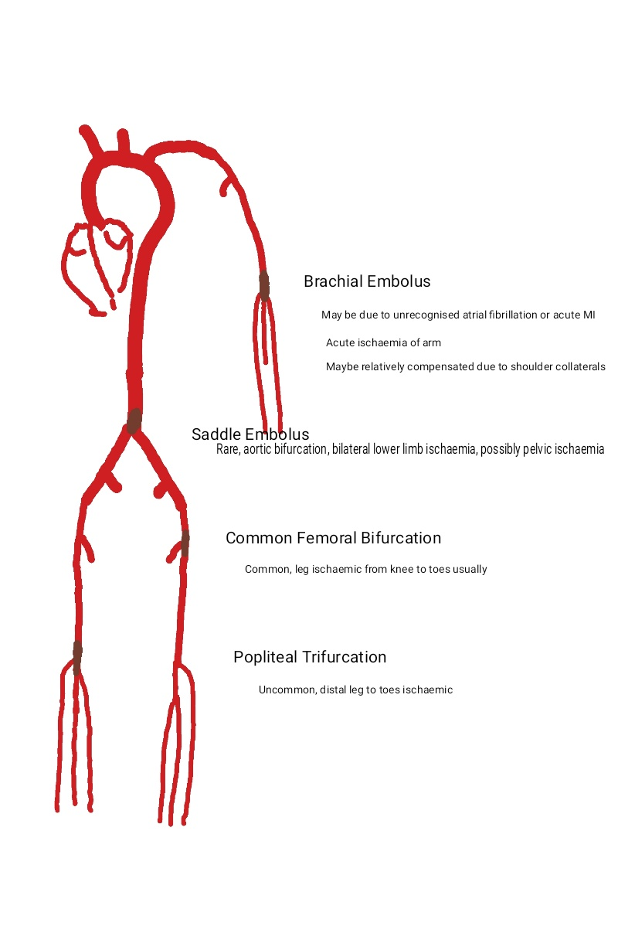

Traditionally 80% embolic: clot travels from a distant source and lodges at a bifurcation point

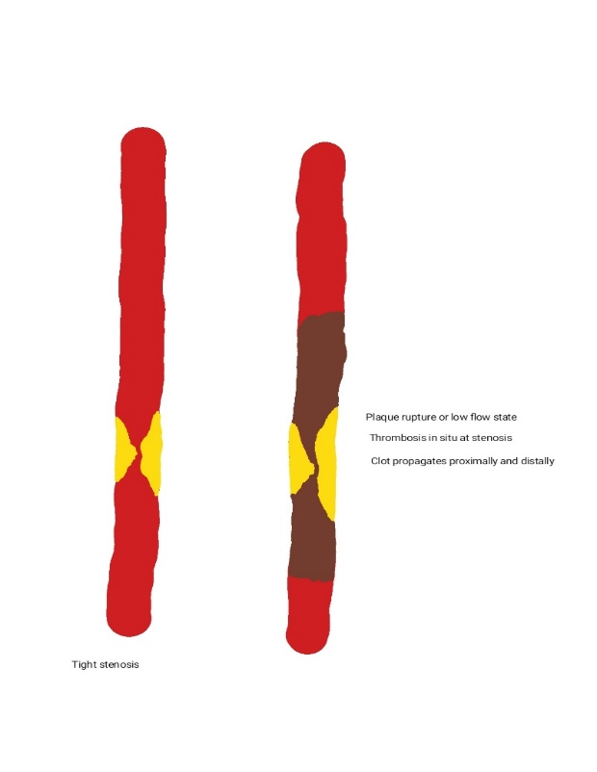

20% Thrombotic: A popliteal aneurysm thromboses or a pre-existing stenosis blocks completely (usual mechanism in acute MI, also occurs in limb arteries).

Practice Point: Embolic is much less common than it used to be. We see more patients with acute on chronic ischaemia due to acute thrombosis on a longstanding tight stenosis. Sudden arterial disruption due to trauma (extrinsic or iatrogenic) accounts for a lot of true acute limb ischaemia these days
Clinical Evaluation
History
Usually present with sudden onset limb pain and pallor. Pins & needles are late signs.
Examination
Affected limb looks pale
No pulses palpable below level of blockage
May be venous guttering
Limb cool
In late stages – reduced sensation compared to other leg, reduced power, muscle tenderness
Fixed skin staining indicates capillary rupture – the limb is likely to be unsalvageable

Investigations
Practice Point: Time is muscle in acute limb ischaemia. Remember irreversible damage occurs within 6 hours of onset NOT within six hours of when YOU meet the patient! The absolute priority is to re-establish arterial flow to the leg. Do not let protracted investigations delay intervention in true ALI

Bloods – full blood count, renal function, clotting, troponin (arrhthymia from an acute MI is a not infrequent cause of an embolic event in a limb)
ECG – are they in fast atrial fibrillation? Have they signs of myocardial ischaemia?
CT or MR angiogram – may be helpful provided they can be performed rapidly and not delay a trip a theatre. Personally, I often just go to theatre and perform an on-table angiogram

Management
If you have a patient with a pale, pulseless, acutely painful leg
Give oxygen (15L per minute via non-rebreathing mask)
IV Access
Analgesia
Heparin 5000 units IV stat
Call vascular
Call anaesthetics
Call theatre and warn them
Interventional Options
Embolic ALI | Thrombotic ALI
Usually embolectomy with Fogarty catheter  Thrombolysis does not generally have a role (travelling bits of chronic organised thrombus are unlikely to respond to lytic agents) | More complex  Maybe a role for thrombolysis if the limb is reasonably compensated and you think there is time  Underlying stenosis will need to be treated to reduce the chance of re-thrombosis  Often end up with an emergency bypass as the quickest route to reperfusion
IN BOTH CASES REMEMBER REPERFUSION MAY LEAD TO RHABDOMYOLYSIS AND COMPARTMENT SYNDROME. CONSIDER FASCIOTOMIES & GIVE LARGE QUANTITIES OF IV FLUIDS TO MINIMISE RENAL DAMAGE

Distinguishing Acute from Acute on Chronic
Acute | Acute on Chronic
Absent pulses in affected limb but normal pulses in contralateral limb  No signs of asymptomatic PAD  Often have precipitant – acute MI, fast AF, trauma | Maybe absent pulses bilaterally  Signs of chronic PAD in affected limb  More likely to be compensated with some capillary return and venous filling

