CHRONIC LIMB THREATENING ISCHAEMIA

Definition: Ischaemic rest pain requiring opiate analgesia for at least two weeks OR tissue loss, typically occurring in the presence of an ankle systolic pressure of <50mmHg or a toe systolic pressure < 30mmHg
Practice Point: The patient must have at least one of either rest pain or tissue loss to be diagnosed with CLTI. Patients pain free without tissue loss but with an ankle pressure below 50mmHg or a toe pressure below 30mmHg have PAD but they do NOT have CLTI

Epidemiology
5 to 10% of asymptomatic PAD or IC patients progress to CLTI in 5 years
50% of CLTI patients have no prior history of PAD
Affects 1.3% US adults at any given time
Develops in 0.3% US adults per annum
Risk Factors
Smoking, diabetes, haemodialysis, hypertension, hypercholesterolemia, family history
Causes
Majority = atherosclerosis
Less commonly vasculitis
Rare: fibromuscular dysplasia, entrapment syndromes, thrombophilias e.g. Protein S deficiency
Clinical Features
Rest Pain
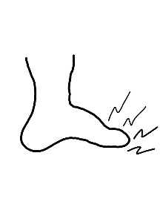
Worse at night
Relieved by leg dependency
Felt across base of toes
Severe, ache or burning

Classic History: A patient spending all night trying to sleep sitting in a chair (leg elevation in bed reduces perfusion to the foot and pain develops)

Tissue Loss
Ulcer OR gangrene
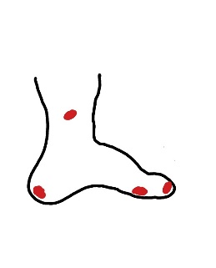
Typically – tips of toes; heads of metatarsals (planta side); tip of calcaneum; lateral malleolus

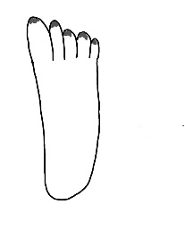
Gangrene may be black, necrotic areas on tips of toes

OR

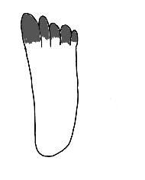
May be more extensive with proximal extension of necrotic tissue

Approach to the CLTI Patient
History and Examination: As per MS04 Clinical Evaluation of Possible PAD AND MSO1 Leg Ulcer Basics
For patients with gangrene, approach history and examination as you would for a leg ulcer
Practice Point: As students, we all like definite management pathways (If patient has Disease x, prescribe Management y). CLTI patients usually have multiple co- morbidities (COPD, advanced diabetes, haemodialysis dependency, strokes and ischaemic heart disease are common). Some will settle down without procedural heroics and 'downstage' from CLTI to asymptomatic PAD. There is NO 'one size fits all’ management plan.

Investigations
Full Blood Count: exclude anaemia
Urea and Electrolytes: check renal function as renal impairment may influence choice of arterial imaging (if any)
proBNP: cardiac dysfunction may influence decisions regarding fitness for interventional procedures
CXR: cardiomegaly? Pulmonary oedema? Undiagnosed lung neoplasm?
ABI or TBI: provides some idea of foot / leg perfusion which may help weigh up the chances of the patient settling with conservative treatment
Imaging
Practice Point: Arterial tree imaging may not always be needed. Some patients may be neither suitable (e.g. very advanced gangrene) nor fit (e.g. wheelchair bound, advanced heart failure) for arterial intervention. In these patients, the only question is whether they are fit for an amputation. Arterial tree imaging will not alter management.
Practice varies from unit to unit but generally one of:
CT or MR Angiogram
Duplex ultrasound
Digital Subtraction Angiogram

Management
STOP SMOKING
Ensure ulcers are offloaded
Optimise diabetic and blood pressure control
Foot care advice (try to avoid the other foot deteriorating)

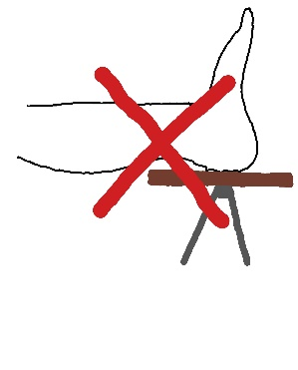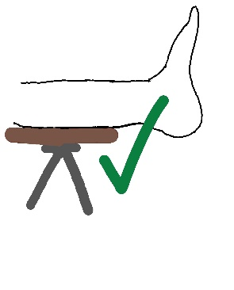
Practice Point: Offloading means 'foot floating free in the air’. NEVER tell CLTI patients to put their foot on a foot stool. Pressure on the poorly perfused calcaneum will rapidly add a heel ulcer to your patient's woes!
Make sure anti-platelet and statin are prescribed
Analgesia
If fit for a procedure, consider endovascular or open revascularisation

Prognosis
Untreated, 20% die and 20% lose their leg by 12 months

Prognosis
Depends on severity
Up to 40% one year limb loss in severe CLTI
Of those undergoing revascularisation, up to 50% lose their limb or die within 5 years

