PERIPHERAL ARTERIAL DISEASE
Definition: Peripheral Arterial Disease (PAD) is narrowing or occlusion of the arteries to the legs, extracranial arteries to the brain, the abdominal viscera and the arms, most commonly due to atherosclerosis
Epidemiology
- Prevalence 10 to 20% of men > 50 years
- Geographical variation
- Increases with age
Clinical Presentation
- Asymptomatic (90%)
- Intermittent claudication (8%)
- Critical limb ischaemia (2%)
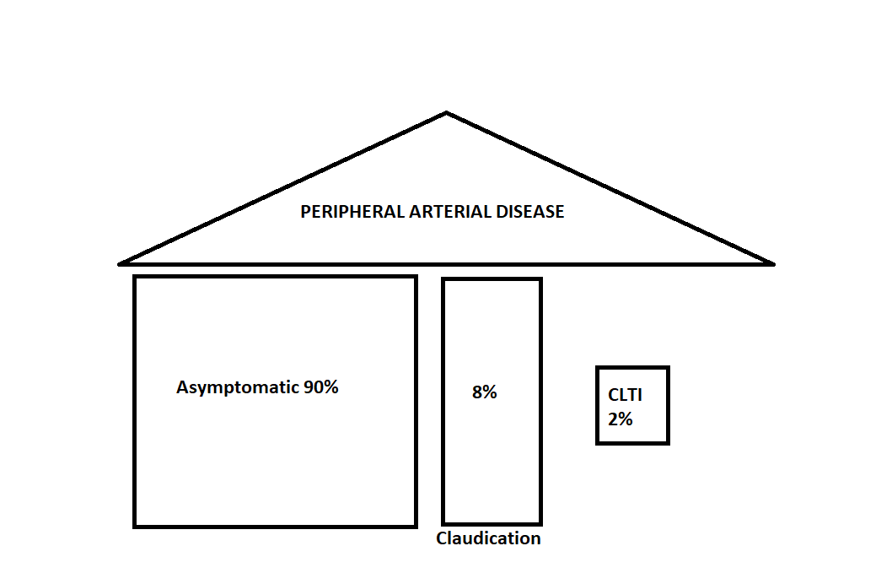
Risk Factors
- SMOKING & SMOKING & SMOKING
- Diabetes
- Long-term haemodialysis (calcium furs up small vessels)
- Previous MI, CVA, TIA, limb ischaemia
- High cholesterol
- Hypertension
- Family history (minor)
Diagnosis
- ABI < 0.9 = PAD
Definition: Ankle Brachial Pressure Index is the ankle systolic blood pressure divided by the brachial systolic blood pressure
- ABI 0.9 to 1.3 = normal
- ABI > 1.3 = calcified vessels so unreliable reading

ASYMPTOMATIC PAD
Clinical Features
It is ASYMPTOMATIC so they will NOT have pain or tissue loss.

May have features in past history that alert you to the possibility:
- Current or ex-smoker
- Diabetic
- Previous ischaemic heart disease, valvular heart disease or cerebrovascular disease (cigarette smoke isn't selective about which pipes it furs up!)
- Previous lower limb revascularisation
- Hypertension
- High cholesterol
May have some physical signs:
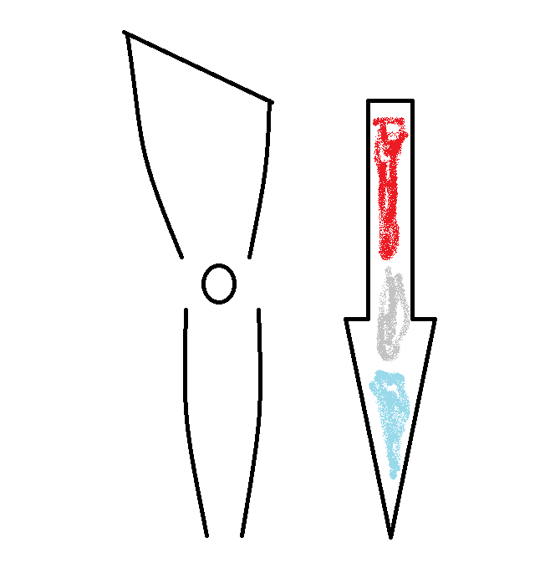
- Proximal to distal temperature gradient in legs (radiators don't work well if the pipes are furred up!)
- Hypertrophic nail changes
- Pallor especially on lifting the legs up from the bed (blood doesn't go uphill well when the pipes are furred)
- Hair loss
- Absent pulses

Diagnosis
- ABI < 0.9 is diagnostic
PRACTICE POINT: A patient with a full set of easily palpable lower limb pulses does NOT have asymptomatic PAD. Do not waste my taxes (and yours) and clog up the vascular laboratory asking for ABIs in that scenario!
Management of Asymptomatic PAD
PRACTICE POINT: The risk of cardiovascular death in patients with PAD is equivalent to patients with coronary or cerebrovascular disease
Reduce their risk factors:
- STOP SMOKING
- Optimise glycaemic control in diabetics
- Start an anti-platelet (One will do, there is no evidence to support routine use of dual anti-platelets in asymptomatic PAD, aspirin is cheapest, the additional clinical benefit of clopidogrel is marginal at best)
- Start a statin (regardless of their cholesterol level, the keen amongst you can look up the Heart Protection Study to work out why)
- It is worth a one-off abdominal aortic ultrasound to rule out an AAA
- Carotid artery screening in this scenario is highly controversial (and the US National Preventive Services Task Force currently recommends AGAINST carotid artery screening as it causes more harm than good...check Wilson's criteria for screening tests and see how many apply to carotid screening)
- Intervention (endovascular or open) has NO ROLE in the management of ASYMPTOMATIC PAD...patients who are pain free with intact tissues should NOT be subjected to endovascular or surgical interventions that risk life and limb!!!

PRACTICE POINT: Do NOT send asymptomatic PAD patients for any type of arterial imaging – they are not candidates for revascularisation and therefore imaging will NOT alter their management...it simply clogs up the system and wastes huge amounts of money!

