CLINICAL EVALUATION OF LOWER LIMB ARTERIAL INSUFFICIENCY: HISTORY TAKING & EXAMINATION

Remember…common things are common, in examinations as well as clinical practice. Stable claudicants and hospitalized CLI patients pop up regularly in examinations, generally as long cases. Make sure you are well practiced at peripheral vascular history and examination by the time you are being examined. The only way to be good at this is to practice and practice and then practice a bit more. No one can do it for you!

Presenting symptoms
Can they describe the pain in their leg?
Where is the pain?
Have they ever had it before?
When did they first notice the pain?
Did it start suddenly or gradually?
Has it got worse since they first noticed it?
Can they describe it? (aching, cramping, sharp etc)
How severe is it?
Does it go anywhere else?
Does anything make it better?
Does anything make it worse?
What do they think caused it? (Most people forget this but not infrequently the patient has a good idea what it is!!)
Does the pain come on when you walk?
How far can you walk before the pain starts? (Use a known objective distance i.e. 100 yards NOT from his front door to the shop!!) **This is key information in determining the most appropriate treatment option in intermittent claudication
Does the pain go away if you rest?
Do you get this pain every time you walk?
How long has this been going on? Is it getting better or worse?
Have you any pain in your toes or foot at rest or in bed at night?
Ask men about erectile dysfunction
If the patient has an ulcer…
When did they first notice it?
How did they notice it?
Has it changed at all since they noticed it?
Has it ever disappeared completely since they first noticed it?
What are the main ways it bothers you? (Appearance, pain, odour etc)
Have you had ulcers before?
Have you any other ulcers at the moment?
What do you think caused it?
Past History
Ask about previous procedures or tests for peripheral vascular disease
Ask about previous MI / CVA / TIA/ PCI / CABG
Risk Factors
Ask specifically about:
Smoking history
Diabetes
High blood pressure
High cholesterol
Family history of cardiovascular disease
Associated symptoms
Ask specifically about
Chest pain
Exertional dyspnea
Leg swelling
Paroxysmal nocturnal dyspnea or orthopnoea

CLINICAL EVALUATION OF LOWER LIMB ARTERIAL DISEASE: EXAMINATION
Introduce yourself – ‘Hello, my name is…’
Ask the patient’s permission to examine them
Expose the patient’s legs from hip to toes

Inspection
From the end of the bed:
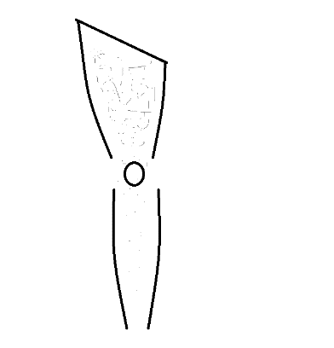
Pale?
Redness?
Bluish toes?
Trophic changes – shiny skin, hair loss, muscle wasting?

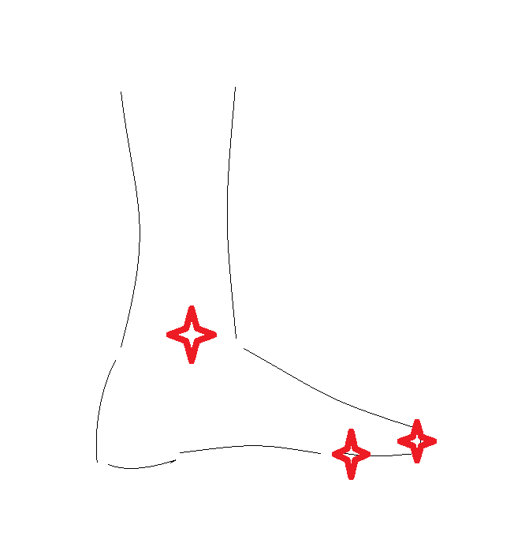
Check for ulcers
- Lateral side of foot especially around at 5th MTPJ
- Head of 1st MTPJ (medial side and plantar aspect)
- Heel (plantar aspect)
- Malleoli
If ulcers present, describe as for any ulcer - Site, size, depth, edge, base, borders, surrounding skin, local temperature

Palpation
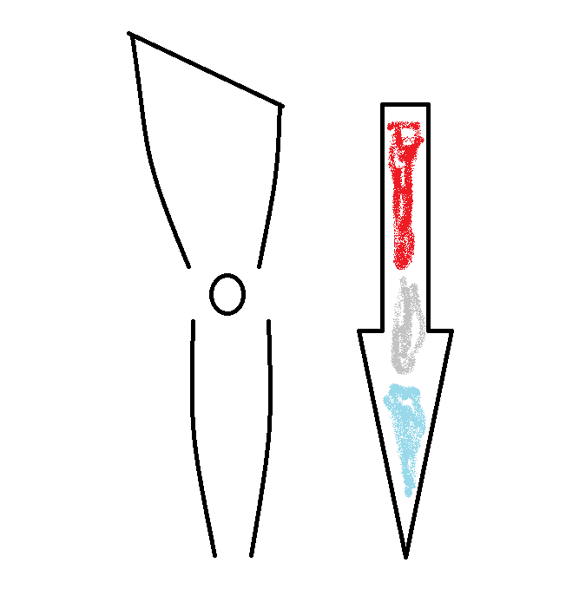
Run the back of your hand proximally to distally along each leg (be sure to use the same hand and to check the same area on each leg – don’t compare the medial side of one leg to the lateral side of the other and don’t use both hands simultaneously!)
Is there a temperature gradient along the leg?
Is it equal both sides?

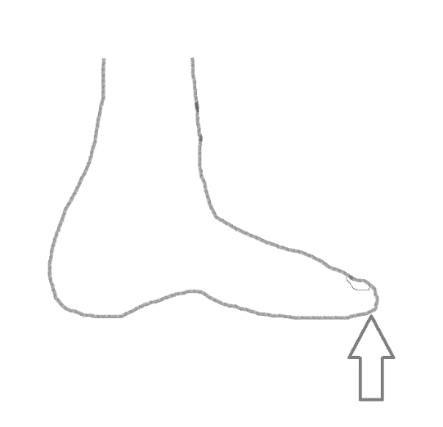
Press the tip of each hallux firmly for five seconds and release
What is the capillary refill time?
Is it delayed (>2 seconds)
Is it equal bilaterally?

Check pulses
For each pulse: Present or absent? Normal volume or diminished? Equal bilaterally? Does the vessel feel soft or hard and chalky? Does it feel expansile i.e. aneurysmal?
START WITH THE FEMORAL PULSE AND WORK YOUR WAY DOWN THE LEG
Inability to quickly locate the right spot to check for lower pulses wakes the examiners up to the fact that you have not practiced this enough – and often leads to a request to demonstrate the patient’s ankle reflux (another embarrassing marker of a practicing deficiency!!)
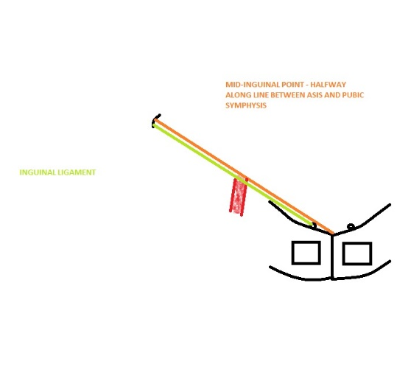
Femoral Pulse: Surface marking: midpoint between anterior superior iliac spine and symphysis pubis i.e. the mid0inguinal point (this is different to the mid-point of the inguinal ligament – surgical examiners love to ask you to explain the difference!!)

Popliteal Pulse: Ask the patient to flex their knee to 90 degrees, place your thumbs on the anterior tibial tuberosity and all your fingers between the heads of gastrocnemius

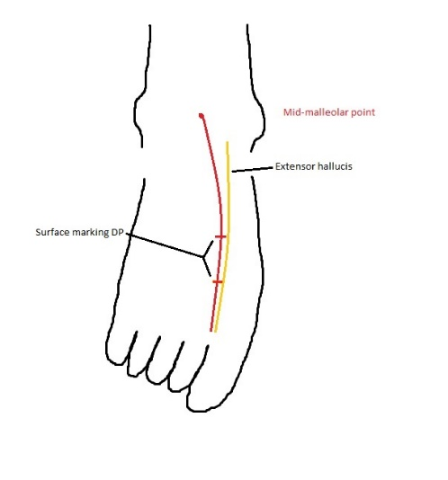
Dorsalis Pedis: Draw a line between the two malleoli, connect the midpoint of this line to the first web-space – the DP pulse should be in the mid-third of the line lateral to the extensor halluces longus tendon. It is impalpable in 15% of the normal population

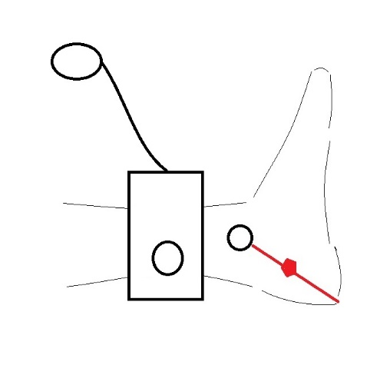
Posterior Tibial: Halfway along a line connecting the tip of the medial malleolus with the tip of the heel – again it is impalpable in about 15% of normal individuals

Percussion
Nothing to percuss on peripheral vascular examination
Auscultation
Use your stethoscope to listen for bruits – renal arteries and each lower limb pulse
Special Maneuvers

Buerger’s Angle: Elevate the leg until the foot starts to become pale
The angle between leg and bed is called Buerger’s angle – anything less than 45 degrees is abnormal
While the leg is elevated look for venous guttering – if present, it suggests that the arterial flow into the foot is not sufficient to keep the veins full

Buerger’s Test: Then ask the patient to sit and swing the leg over the edge of the bed. Does it turn very red after a minute or so? If yes = reactive hyperaemia and a positive Buerger’s TEST (note there is Buerger’s angle AND Buerger’s test – they are not the same thing!)

