INVESTIGATING & MANAGING PATIENTS WITH LEG ULCERS

History & Exam
Something else?
Neuropathic?
Arterial?
Venous?

VENOUS?
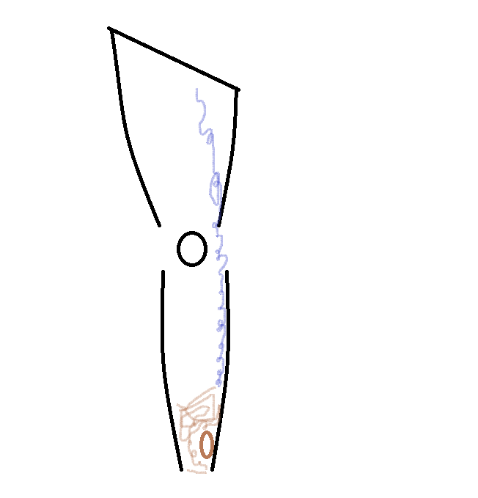

Suspect if obvious varicose veins, haemosiderin around ulcer, champagne bottle leg
Some patients will have haemosiderin and lipodermatosclerosis with minimal surface varices or just lots of thread veins and blue blebbing
The ulcers are usually (but by no means always) around the medial malleolus

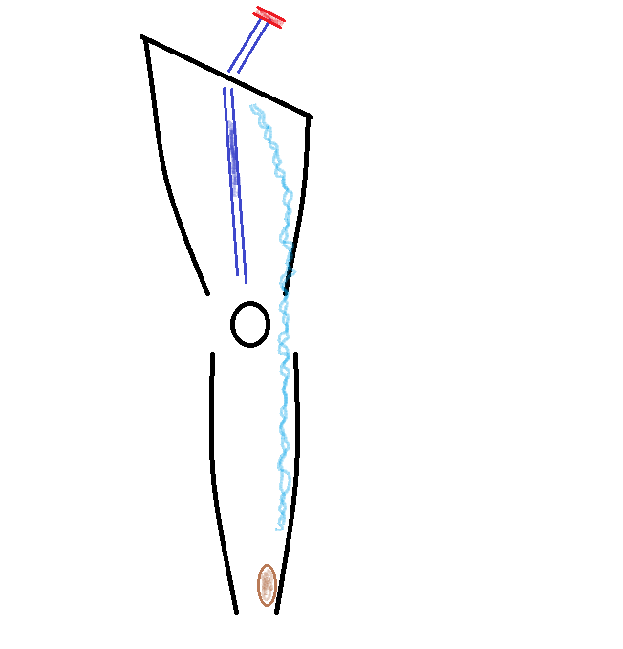
If your patient has a previous history of DVT or PE or leg or pelvic surgery, consider the possibility of a deep vein lesion which may produce a venous ulcer
Typically these patients have a lot of haemosiderin, some leg swelling and blue blebbing. They often do not have much by way of obvious varices although sometimes they develop superficial varicose veins due to the high pressure in their deep system

Check the pulses in the affected leg
  - Easily palpable pulses?
  - If not easily palpable check an ABI
  - If pulses easily palpable OR ABI normal (numbers AND waveform) – likely venous

You have decided that the ulcer is venous – now what?
PRACTICE POINT: Venous leg ulceration (VLU) is fundamentally a plumbing issue. Skin and tissue is chronically damaged due to high venous pressure which competes with arterial inflow pressure at the capillary beds, reducing tissue perfusion pressure at the microcirculation level.

PRACTICE POINT: The key to healing venous ulcers is to REDUCE THE VENOUS PRESSURE. As the pressure on the venous side of the microcirculation falls, cell and tissue perfusion increases

PRACTICE POINT: Lotions, potions, dressings, bandages and neat electronic widgets may (or may not, the evidence base is thin) CONTRIBUTE to certain aspects of VLU care but in the absence of venous pressure reduction they are not the solution

Venous pressure reduction
  - Encourage patient to get off their feet and get their leg up in the air
  - Start a compression bandage ( explain it has to be tight to do its job)
  - There is good evidence that early varicose vein ablation under local anaesthetic improves ulcer healing times and reduces recurrence – I offer it to most of my VLU patients on their visit
  - If there are reasons to suspect a deep vein issue (previous history, previous leg or pelvic surgery, strong family history) consider screening the deep system with a CT Venogram to determine if deep vein intervention (stenting or venoplasty) is needed.
Other elements to VLU care
- STOP SMOKING
- Encourage adequate nutrition – do they need diet supplements?
- Check FBC for anaemia

ARTERIAL?
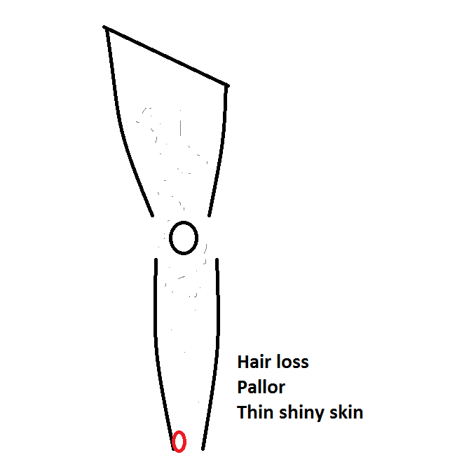
Suspect if cool leg, pale, thin shiny skin, hair loss, trophic nail changes, diminished or absent pulses
Classically described as punched out and over lateral malleolus – not always true in practice because patients do not read our books!
If clinical features of arterial disease are absent but impalpable pulses / reduced ABI, let the thought of an arterial element cross your mind!
Arterial ulcer = tissue loss = Chronic Limb-Threatening Ischaemia (CLTI)
PRACTICE POINT: CLTI is NOT the same as acute limb ischaemia (the famous) 6Ps. In the absence of ascending infection, these patients need an urgent vascular clinic assessment but they do NOT generally need to be rushed to hospital the instant they first present

You have decided that the ulcer is arterial – now what?
Just like for VLU patients
- STOP SMOKING
- Encourage adequate nutrition – do they need diet supplements?
- Check FBC for anaemia

This is also a plumbing issue.
- Are they a candidate for revascularisation (endovascular or open)
- If yes – image the arterial tree on the affected side from aorta to toes and plan from there
- If no – are they a candidate for palliative amputation?

NEUROPATHIC?
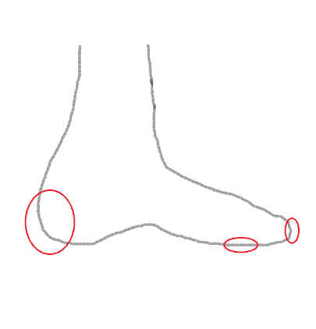
Typically occur on pressure areas – tips of toes from footwear, plantar aspect of foot over heads of metatarsals, calcaneum from pressure on bed or footwear
Classically described as punched out but (yet again) does not always hold true!
Most commonly seen in diabetics but can occur due to any neurological issue
Check the pulses OR ABI – diabetics may not heal a neuropathic ulcer due to underlying arterial disease in which case they may need to be treated just like an arterial ulcer
Exposed bone or tendon? Foot x-ray to check for osteomyelitis
Pulses / ABI OK? No features to suggest osteomyelitis? OFFLOAD – get all the weight off the ulcer, get the patient off their feet
Pulses / ABI NOT OK? Treat as for arterial
Evidence of osteomyelitis? May require bone debridement / excision, amputation and / or long-term antibiotics

SOMETHING ELSE?
Neuro-ischaemic

Mixed Venous / arterial
Venous
Arterial
Neuropathic

If the ulcer does not fit in the Venn diagram think of rare causes – a punch biopsy should be taken to rule out malignancy or vasculitis, consider an autoimmune screen
PRACTICE POINT: You will notice that I have not mentioned antibiotics except in the context of osteomyelitis. Antibiotics will not heal plumbing-related ulcers (venous, arterial, mixed) in the absence of corrective action to the plumbing! In the absence of active infection, they are not indicated. Unfortunately, patients and medical professionals frequently believe that all is needed is another round of antibiotics!

