CHECKING & INTERPRETING ANKLE-BRACHIAL PRESSURE INDEX
Simple measure to determine if a patient has peripheral arterial disease
Needs: manual blood pressure cuff and a handheld Doppler
“Take measurements manually using a Doppler probe of suitable frequency in preference to an automated system”
UK National Institute of Health and Clinical Excellence ‘Lower limb peripheral arterial disease overview’ 2016

Method
Patient lies supine for 10 minutes
Place BP cuff just above the malleoli (use a clingfilm wrap to protect the patient from the cuff)

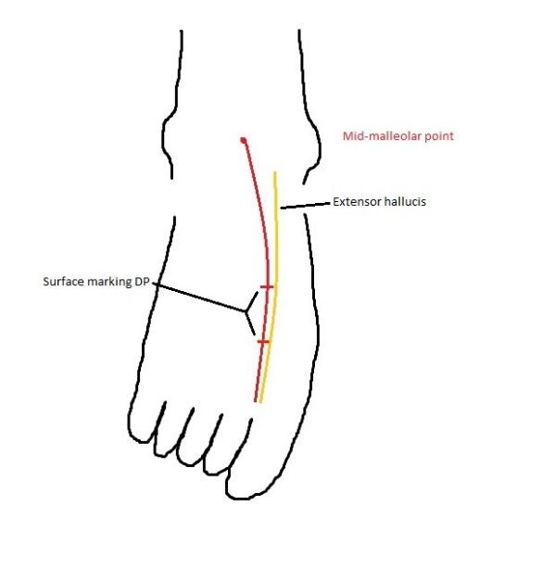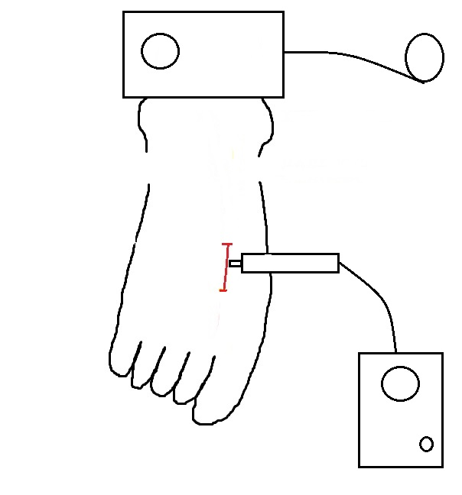

Locate the dorsalis pedis pulse using the Doppler
The DP pulse lies in the mid-third of a line connecting the mid-malleolar point with the first webspace, immediately lateral to the extensor halluces longus tendon – this is a favourite exam question in final med and membership level exams
Inflate the cuff until the Doppler signal disappears
Slowly deflate the cuff and note the pressure at which the Doppler signal reappears

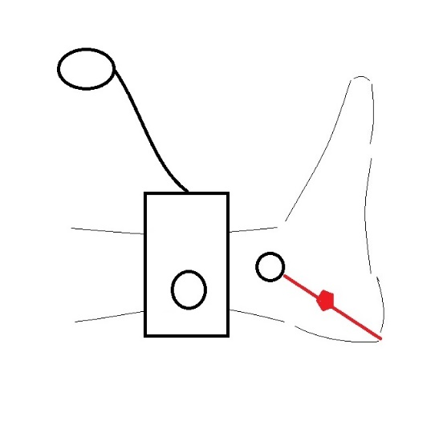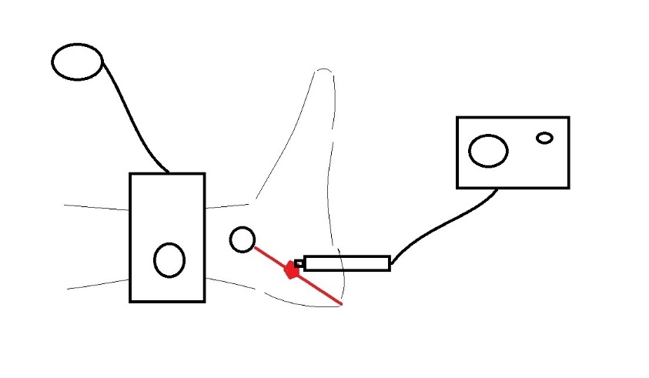

Locate the posterior tibial pulse and repeat the inflation / deflation sequence noting the pressure at which the posterior tibial signal reappears
PT lies midway along a line joining the medial malleolus to the calcaneal tip
Move the cuff to the ipsilateral upper limb
Locate the brachial pulse in the antecubital fossa using the Doppler probe (remember your surface anatomy – it lies immediately medial to the biceps tendon in the antecubital fossa)
Repeat the inflation / deflation sequence and record the pressure at which the brachial Doppler signal reappears
Repeat the entire sequence for the other leg

Calculate the following:
ABPI = Highest ankle systolic pressure (the highest of the PT or DP value for that leg) divided by the brachial systolic pressure

- People often get the ABI formula the wrong way round so write it vertically to remember
A
/
B
=
I

ABI Interpretation
Interpretation involves assessing the numbers AND the sounds
Numbers
<0.9 | Peripheral arterial disease present (NOTE this does not necessarily mean either IC or CLI)
0.9 to 1.3 | Normal
>1.4 | Calcified stiff vessels – if there are concerns then toe pressures MAY be indicated
Toe pressures are indicated in limited circumstances only, absorb laboratory time and should NOT be performed routinely
Sounds
Can be triphasic (normal), biphasic (maybe normal, maybe disease), monophasic (disease)
Triphasic
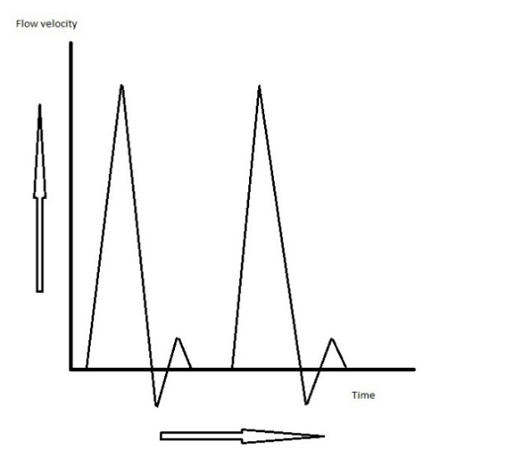 Big upstroke in systole, sharp fall in diastole then a small upkick due to elastic recoil in healthy arteries

Biphasic 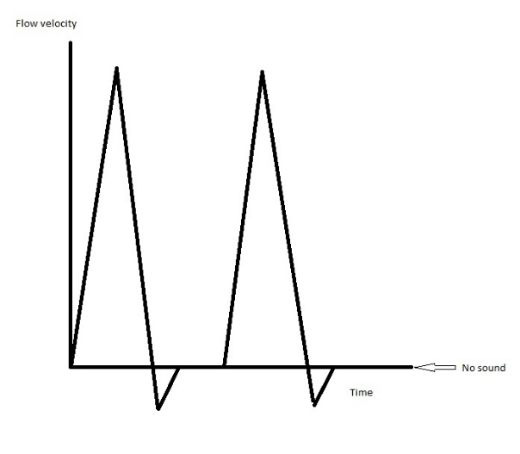Still a big systolic upstroke followed by a diastolic downstroke but elastic recoil lost so no upkick – might be aging, hardened arteries or might be pathological

Monophasic
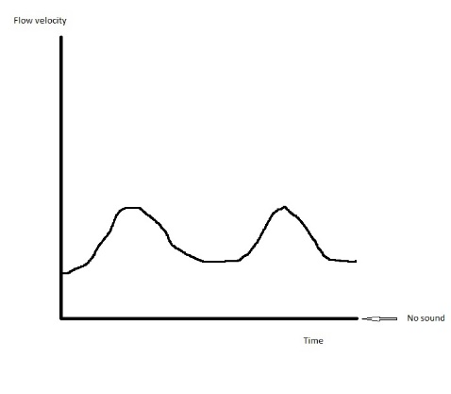Low amplitude flow (lower peaks), slower rise and fall

FURTHER READING (FOR THE KEEN AMONGST YOU)
Interpretation of peripheral arterial and venous Doppler waveforms: A Consensus Statement from the Society for Vascular Medicine and Society for Vascular Ultrasound. DOI link: https://doi.org/10.1177/1358863X20937665
Diagnostic Performance of Ankle-Brachial Pressure Index in Lower Extremity Arterial Disease. DOI: 10.1055/s-0041-1731444

