MS01 ASSESSING & EVALUATING A PATIENT WITH LEG ULCERS
Definition: an ulcer is a discontinuity in an epithelial surface

Basic Leg Ulcer Epidemiology
Common – about 1% of people >70 years at any given time
Recur frequently – about 1 in 3 recur within 1 year of healing
Types of leg Ulcers
- Venous – 70%
- Arterial – 20%
- Traumatic or tuberculous
- Inflammatory (e.g. vasculitis) or infectious (e.g. strep)
- Neuropathic (9%) or Neoplastic

Aetiology
TYPE | CAUSE | UNDERLYING PATHOLOGY
Venous | Superficial venous insufficiency  Deep venous insufficiency | Varicose veins  Previous deep vein thrombosis  May-Thurner syndrome  Non-thrombotic iliac venous lesions
Arterial | Large vessel disease  Small vessel disease (vasculitis) | Atherosclerosis, Buerger’s Disease  Rheumatoid arthritis  Polyarteritis nodosa
Traumatic | Neuropathic  Others | Diabetes mellitus  Spinal cord problems e.g. chronic cord compression  Alcohol  Pressure ulcers  Accidental
Infective | Often element of malnutrition | Strep pyogenes and other pyogenic organisms  Tertiary syphyllis (mercifully now exquisitely rare!)
Neoplastic | Primary neoplasm  Secondary (usually appear as an ulcerated nodule) | Squamous cell  Basal cell  Melanoma  Adenocarcinoma (lung, bowel)

Focussed History Taking
- How long has the ulcer been there?
- How did you first notice it?
- Has it changed since you first noticed it?
- Has it ever completely disappeared since you first noticed it?
- Is it painful?
- Is there a smell?
- Has it been dressed or treated in any way?
- Do you have any other ulcers or lumps anywhere else?
- Are you a smoker?
- Are you diabetic?
- Do you get any pain in your calf or thigh when you walk?
- Ever had a clot in the leg or lung?
- Have you any varicose veins?

Examination
Introduce yourself – ‘Hello, my name is…’
Ask the patient’s permission to examine them
Expose the patient’s legs from hip to toes
Inspect:
Where is the ulcer? Measure from nearest bony prominence (with a tape measure not a guess!)
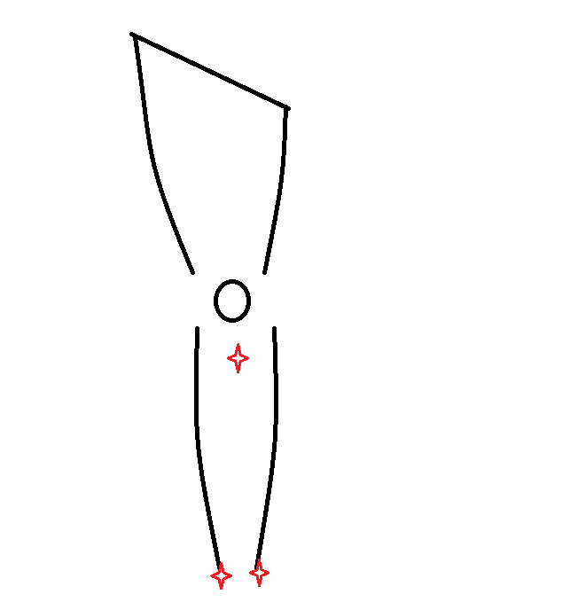

Handy bony prominences are the medial or lateral malleolus or the tibial tuberosity – classically venous ulcers lie over the medical malleolus and arterial ulcers lie over the lateral malleolus – this does not always hold true in reality!
What shape is the ulcer? Oval, round, irregular, linear?
What size is the ulcer? Measure long and transverse axes with a tape measure

Look at the base and comment

Red and granulating?


Or sloughy or pus in areas?


Check penetration – is there visible tendon?


Or is there exposed bone?

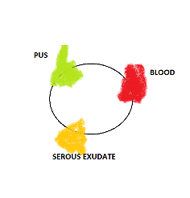
Is there discharge? Pus, serous exudate or blood?
Look at the edge and comment
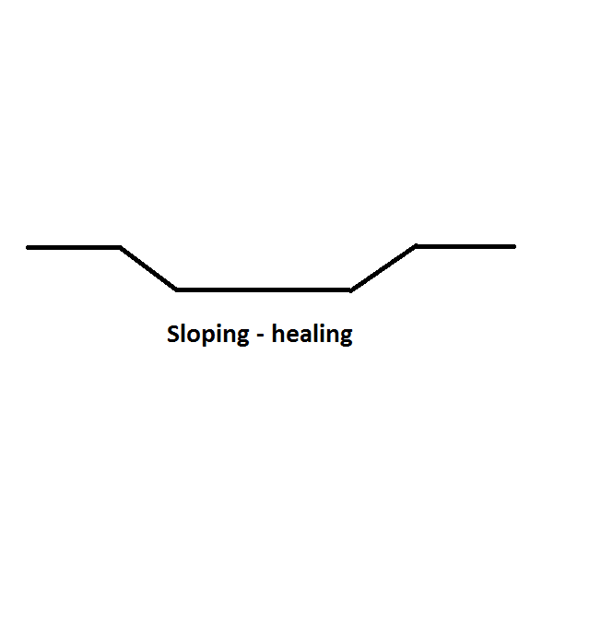
Gently sloping edges suggest a healing ulcer

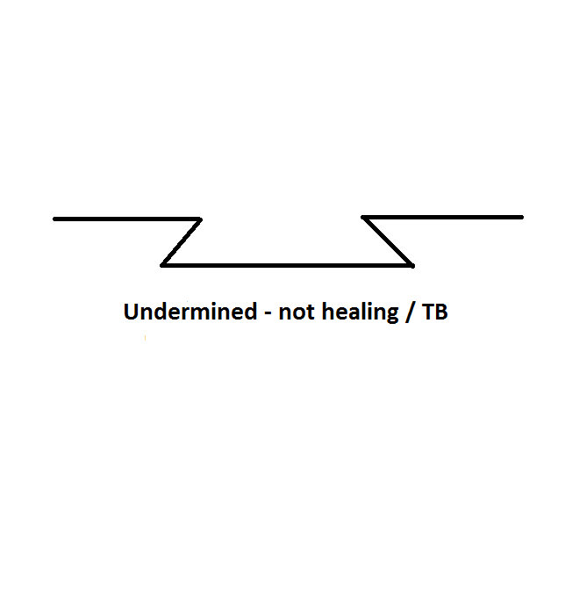
Undermined edges suggest non-healing / progressive ulcer. On rare occasions, it may indicate TB

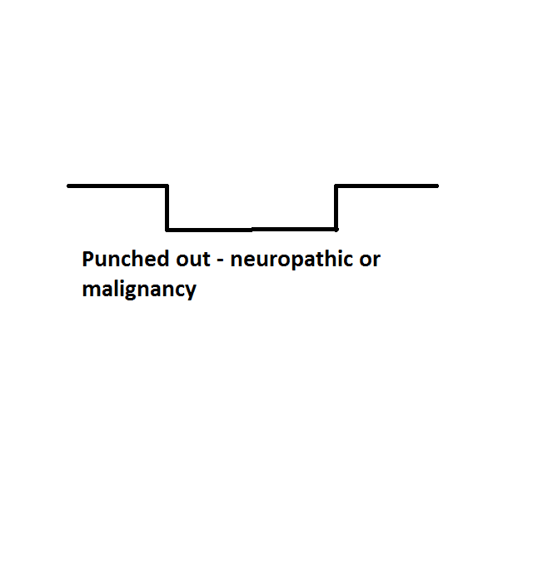
Punched out appearance in cross section is typical of arterial or neuropathic ulcers

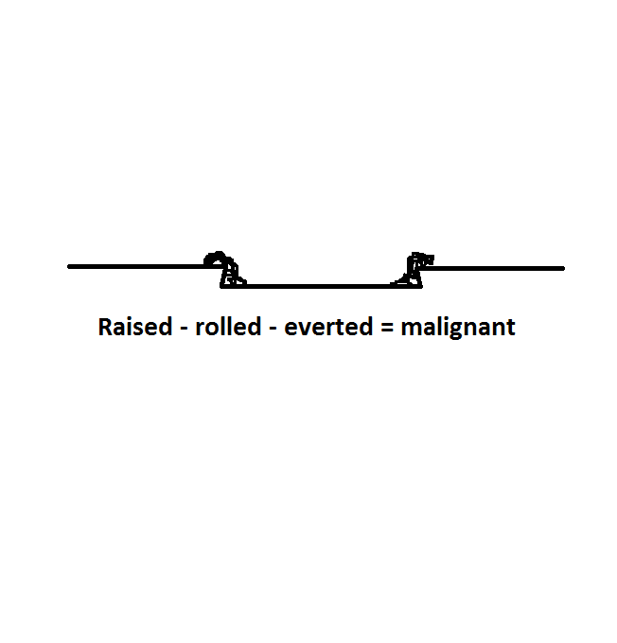

Raised, rolled, everted edges are typical of a malignant ulcer

How deep is the ulcer? Get your tape measures again or a probe and check depth in millimetres

Look at the surrounding skin and comment

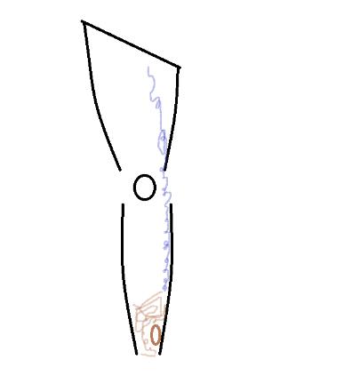

Visible varicose veins, brown skin staining in the gaitre area (haemosiderin), champagne bottle leg deformity (from lipodermatosclerosis) all suggest a venous ulcer

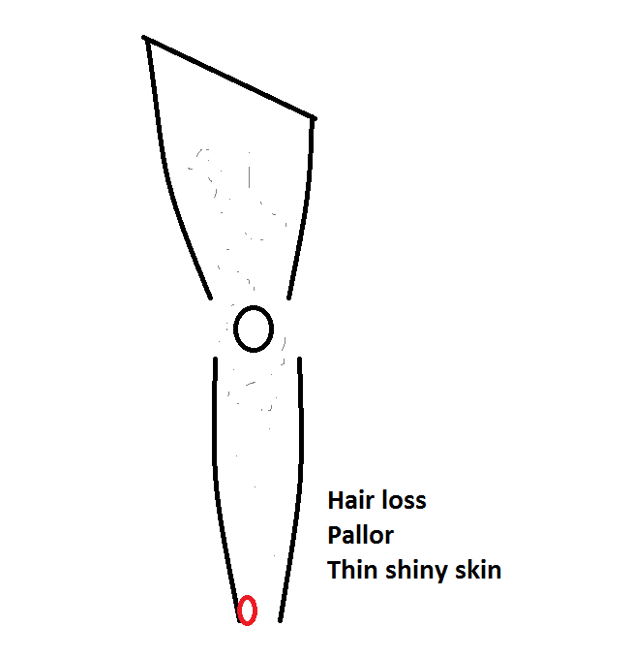

Hair loss, thin shiny skin and pallor all suggest an arterial ulcer

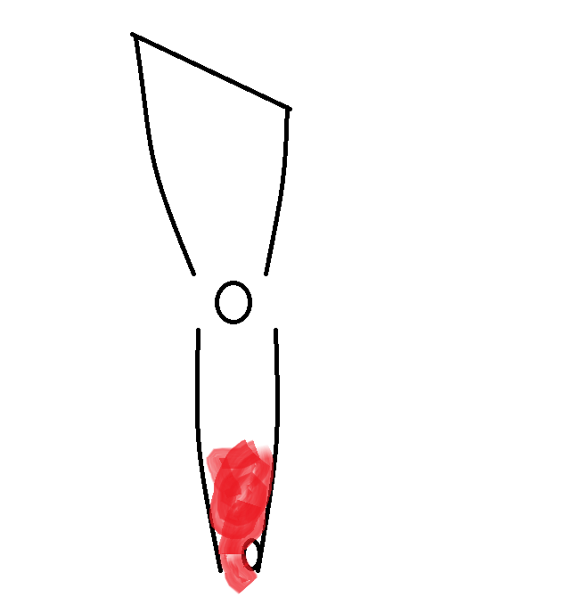

Surrounding skin erythematous – is it cellulitis?

Palpation
- Check they are not in pain
- Use the back of your hand to check the temperature of the surrounding skin AND COMPARE TO THE SAME AREA ON THE OTHER LEG – if its warmer around the ulcer, consider infection

Percussion & Auscultation
- No routine role in leg ulcer assessment

Examine related structures
- Regional lymphadenopathy – check inguinal lymph nodes
- Pulses – check lower limb pulses
- Check sensation – is there a neuropathic element?

Distinguishing neuropathic from arterial ulcers
This tends to cause a bit of confusion
 | Ischaemic ulcer | Neuropathic ulcer
Is the ulcer painful? | Painful | Painless
Is there associated black eschar? | Present | None
What temperature is the surrounding skin? | Cold | Warm
Is sensation intact? | Intact | Lost
Practice point: Ulcers may be mixed venous / arterial – usually this starts as a venous ulcer but healing is impaired by underlying asymptomatic peripheral arterial disease


