MS 31 SURGICAL FLUID MANAGEMENT
Basic Physiology
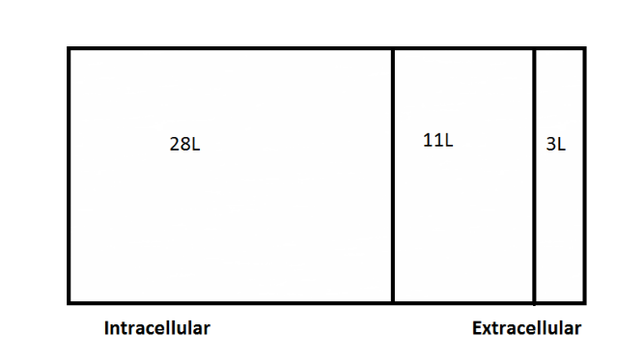
For a 70 kg adult:
Total body water = 42L
Total body sodium = 4200mmols (50% intracellular)
Total body potassium = 3500 mmols (almost all intracellular)

Normal Losses
These need to replaced just to keep the patient in ‘status quo’
Fluid Losses | Electrolyte Losses
Urine 1200 to 1500 mls | Sodium 100 mmols
Respiratory 500 to 700 mls | Potassium 70 to 100 mmols
Sweat 200 to 400 mls | Chloride 150 mmols
Faeces 100 to 200 mls

Normal maintenance requirements
Water = Rule of 10s – 100mls / kg/ 24 hrs for the first 10kgs, 50mls/kg/24hrs for the next 10 kgs then 20 mls/kg/24 hours
Sodium requirement in mmols/24hrs = weight in kgs + 40
Potassium requirement in mmols/24hrs = weight in kgs
Usually use crystalloids for maintenance
Crystalloids
 | Normal Saline | 5% Dextrose | Hartmanns
Sodium | 150 | 0 | 131
Chloride | 150 | 0 | 111
Potassium | 0 | 0 | 5
Bicarbonate | 0 | 0 | 29
Calcium | 0 | 0 | 2
5% dextrose distributes through TBW
Saline and Hartmanns initially remain in extracellular compartment

May use colloids for fluid challenges
Colloids
 | Volume effect (%) | Average MW (kDa) | Circulatory half life
Gelatins (Haemaccel) | 80 | 35 | 2-3 hours
4% Albumin | 100 | 69 | 15 days
Dextran 70 | 120 | 41 | 2-12 hours
6% Hydroxyethyl Starch | 100 | 70 | 17 days

Determining fluid requirements for post-operative patients
Normal losses + abnormal losses = fluid and electrolyte requirements
Abnormal losses
Pre-operative / pre-admission – vomiting, bleeding etc
Post-operative – vomiting, nasogastric aspirate, third space losses, fistula output, drain output, stoma outputs
Most ‘surgical losses’ are sodium rich replace with a sodium rich fluid

Complications of fluid management
Volume-related – congestive cardiac failure, pulmonary oedema, acute kidney injury, cerebral oedema
Electrolyte-related – hyponatraemia, hypernatraemia, hypokalaemia, hyperkalaemia, ileus, arrhythmias, hyperchloraemic metabolic alkalosis

